Montenegro’s Medium (MM): a serum free, low-cost axenic medium enabling robust Naegleria fowleri growth

Authors
Montenegro-Calla, L. J.; Daniel Clark, — Department of Microbiology, Weber State University, Ogden, Utah.
Keywords: Naegleria fowleri, axenic culture, serum free medium, passage timing, direct transfer
Abstract
We developed a simple serum free medium (Montenegro’s Medium, MM) that supports axenic growth of Naegleria fowleri. MM uses common ingredients, no antibiotics, and standard sterile technique. Mean cell density rose from 2.05×10⁵ to 1.72×10⁷ cells·mL⁻¹ across 168 h. A single-phase fit across 0–168 h gave a doubling time near 28 h, with faster early windows of about 12 h (0–24 h) and 9 h (24–48 h). Fresh batches outperformed 30–35-day batches at 48 h (≈1.55×) and 72 h (≈2.77×). Direct transfer worked best when passaged on Day 3 (TD3); at TD4 the two methods were close, and at TD5 they were similar. All experiments came from the same initial batch (2.05×10⁵ cells·mL⁻¹ at T0) expanded in three source flasks and then subcultured more than fifty times without loss of routine growth. A cost check places MM at $0.12–$0.36 per 100 mL versus $8–$23 per 100 mL for serum-dependent formulas. These results offer an accessible option for labs that work with N. fowleri [1–10].
Introduction
Primary amebic meningoencephalitis is rapidly fatal. Work on N. fowleri depends on reliable axenic growth. Many classic recipes include serum, which adds cost, lot variability, and extra unknowns in cultures [10]. Experiments proceed in BSL-2 with a local risk assessment that follows BMBL guidance [1]. Here we report the performance of a serum free medium, MM, and compare it with common media classes such as Nelson-type formulations and DMEM with fetal bovine serum (FBS) [2–4,9].
Methods
Biosafety and organism
Experiments were conducted under BSL-2 practices per institutional review, following BMBL recommendations for risk assessment and mitigation [1]. A laboratory-maintained Naegleria fowleri culture in routine use at Weber State University was used throughout.
Medium preparation and storage
Prepare 1 L of MM in double-distilled water. Combine salts in the order shown in Table S2, then add glucose and liver infusion powder. Bring to volume with water. Sterilize through a 0.22 µm PES filters into a sterile bottle. Record lot and date. Store at 4 °C in the dark. Use within 1–2 weeks. Warm to room temperature and mix gently before use. Serum is not used
Culture vessels and incubation
T-25 flasks with 5 mL were used first, then T-75 flasks with 15 mL. Incubation was at 37 °C with 5% CO₂. Brightfield images were taken on a Leica DMi1 with a 10× objective [8].
Culture lineage and replicate structure
At T0 we prepared three flasks in MM, each seeded to 2.05×10⁵ cells·mL⁻¹. All downstream work (Experiments 1–3) drew daughter flasks from these sources at defined times. Over the project we subcultured more than fifty times under the same incubator settings (37 °C, 5% CO₂). We did not apply stress, serum shifts, starvation, or limiting dilution. Replicates within each experiment were separate daughter flasks, handled in parallel, and counted independently.
Experimental design
Three experiments were run:
- Time course in MM with samples at 0, 24, 48, 96, and 168 h.
- Fresh MM batch (≤7 days) versus old (30–35 days) MM at 48 h and 72 h, with the same starting density.
- Passage timing and method: Day 3 (TD3), Day 4 (TD4), Day 5 (TD5); direct transfer (DT) versus centrifuge transfer (CT at 3000×g, 5 min). Daughter flasks were 12.0 mL total with a 5.0×10⁴-cell inoculum (start ≈4.17×10³ cells·mL⁻¹).
Counting and viability
Counts used a glass hemocytometer at 10×. The four outer squares were averaged with a 1:10,000 dilution. Trypan blue exclusion was used when stated [6].
Contamination screening
Dish microscopy was performed. No contamination was observed in cultures.
Comparator medium
Comparator runs used DMEM with 10% FBS. Nelson-type and PYNFH-type media are provided as context for historical. [2–4].
Statistics
Repeated measures within flasks were analyzed with mixed effects models on log counts. We used a random intercept for flask and fixed effects for condition and time. Ratios of means are reported with 95% confidence intervals. Methods followed standard practice for mixed-effects modeling [7].
Results
Serial passaging
All experiments traced back to the same initial batch at 2.05×10⁵ cells·mL⁻¹ prepared in three source flasks. We maintained routine growth through more than fifty serial passages in MM under the same conditions, with no loss of handling ease and no contamination detected on weekly screens.
Time course growth in MM
Mean density increased from 2.05×10⁵ cells·mL⁻¹ at 0 h to 8.22×10⁵ at 24 h, 5.11×10⁶ at 48 h, 1.03×10⁷ at 96 h, and 1.72×10⁷ at 168 h. A single-phase fit across 0–168 h gave a doubling time near 28 h. Early windows were faster (≈12 h for 0–24 h; ≈9 h for 24–48 h).
Fresh versus old MM
Fresh MM produced higher yields than 30–35-day batches. At 48 h, the mean Fresh:Old ratio was ≈1.55. At 72 h, the ratio was ≈2.77. Batch age affected yield and should be controlled
Passage timing and transfer method
Direct transfer matched or beat centrifuge transfer at all timings. The gap was widest at TD3 (≈1.30 at 72 h). At TD4 the two methods were close. At TD5 they were similar with overlapping ranges. DT at TD3 is the simplest default because it needs no spin and keeps yield high.
Discussion
MM supported axenic growth of N. fowleri with routine tools and simple handling. Removing serum lowered cost and avoided lot variability that often complicates culture work [10]. Nelson-type media remain a benchmark and include balanced salts, glucose, liver infusion, and serum, usually at 37 °C [2,3]. The present better results, showing that a serum free option can perform well while keeping the recipe short and the budget low. We kept steady growth across an extended series of routine passages that all traced back to the same starting batch, which supports day to day use of MM in a standard lab setting
Data and materials availability
Raw counts, analysis code, and redacted SOPs will be provided at submission. Full SOP and batch sheets are available upon request to qualified laboratories with BSL-2 facilities and IBC approval [1].
Acknowledgments
I thank Dr. Daniel Clark, Chair of the Department of Microbiology, for guidance and support.
Author contributions
J.L.M-C., D.C designed the medium and experiments, collected data, and drafted the manuscript. D.C. advised on design and reviewed the manuscript.
Competing interests
The authors declare no competing interests.
References
- CDC & NIH. Biosafety in Microbiological and Biomedical Laboratories, 6th ed. U.S. Department of Health and Human Services, 2020. CDC
- ATCC. Medium 710: Nelson’s Culture Medium for Naegleria. Accessed 2025. https://www.atcc.org
- Schuster FL. Cultivation of pathogenic and opportunistic free-living amebas. Clin Microbiol Rev. 2002;15(3):342-354. doi:10.1128/CMR.15.3.342-354.2002
- Zaongo SD, Shaio MF, Ji DD. Effects of culture media on N. fowleri growth at different temperatures. J Parasitol. 2018;104:451-456. doi:10.1645/18-6
- Russell AC, Kyle DE. Differential Growth Rates and In Vitro Drug Susceptibility to Currently Used Drugs for Multiple Isolates of Naegleria fowleri. Microbiol Spectr. 2022;10(1):e0189921. doi:10.1128/spectrum.01899-21
- Strober W. Trypan Blue Exclusion Test of Cell Viability. Curr Protoc Immunol. 2015;111:A3.B.1-A3.B.3. Published 2015 Nov 2. doi:10.1002/0471142735.ima03bs111
- Bates D, Mächler M, Bolker B, Walker S. Fitting Linear Mixed-Effects Models Using lme4. J. Stat. Soft. [Internet]. 2015 Oct. 7 [cited 2025 Oct. 11];67(1):1-48. Available from: https://www.jstatsoft.org/index.php/jss/article/view/v067i01
- Leica Microsystems. DMi1 inverted microscope: product info. Accessed 2025. Leica
- Lee KK, Karr SL Jr, Wong MM, Hoeprich PD. In vitro susceptibilities of Naegleria fowleri strain HB-1 to selected antimicrobial agents, singly and in combination. Antimicrob Agents Chemother. 1979;16(2):217-220. doi:10.1128/AAC.16.2.217
- van der Valk J, Bieback K, Buta C, et al. Fetal Bovine Serum (FBS): Past - Present - Future. ALTEX. 2018;35(1):99-118. doi:10.14573/altex.1705101

Figures
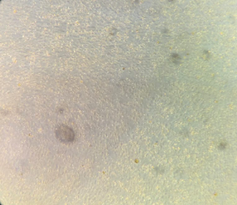  A | 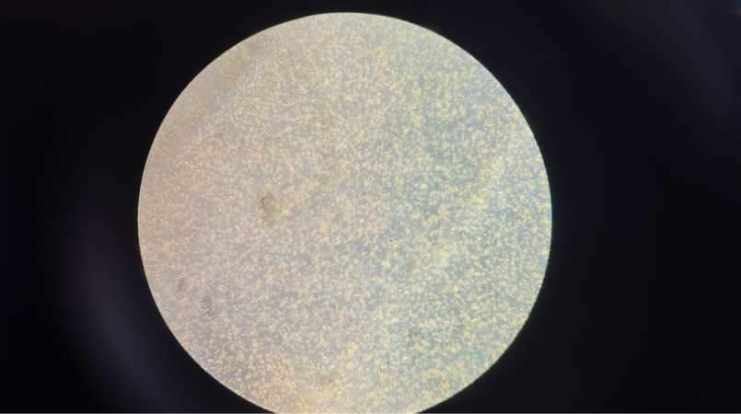  B
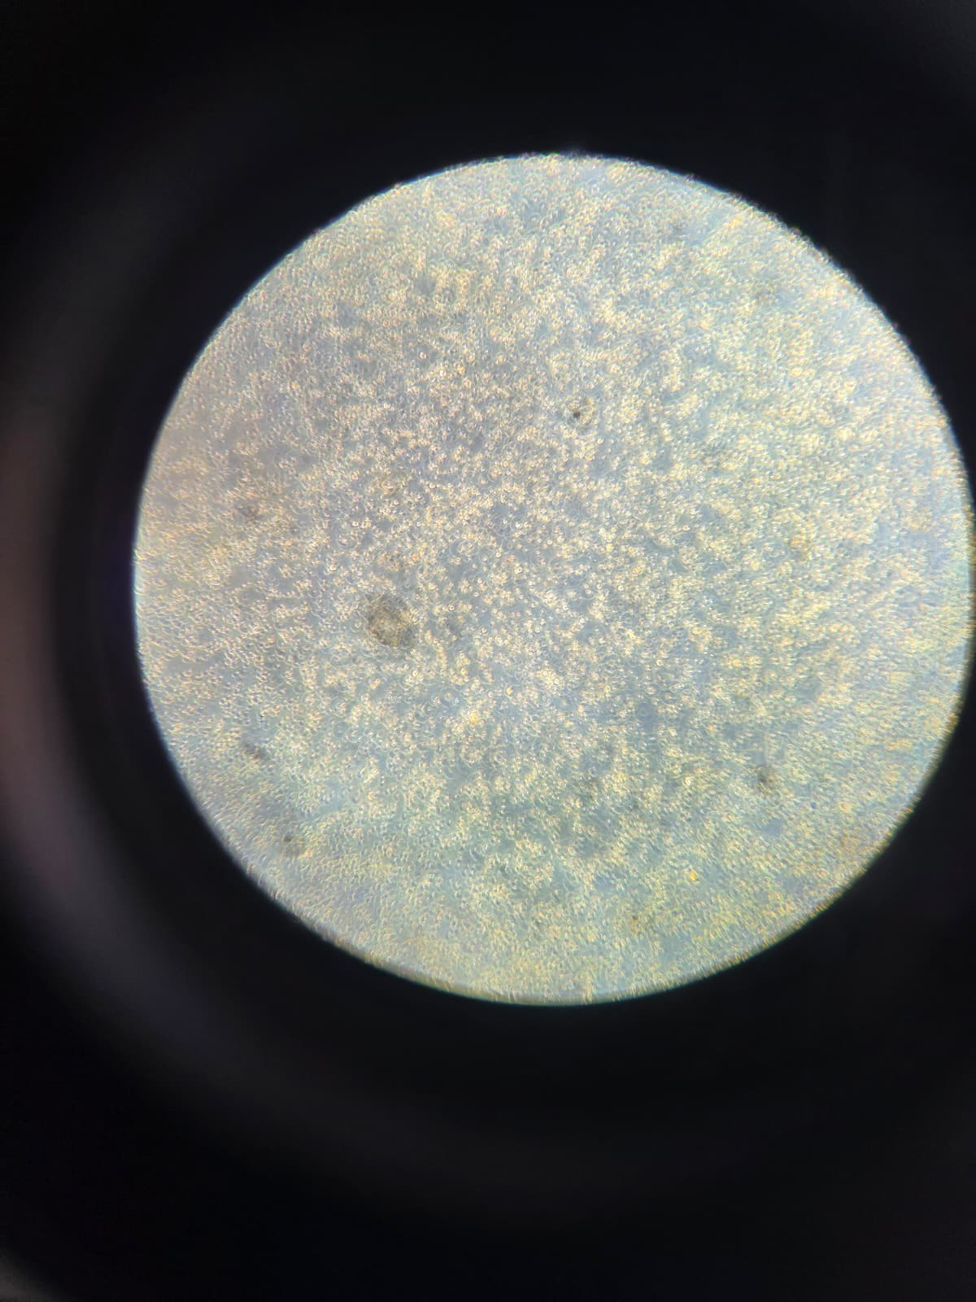  C | 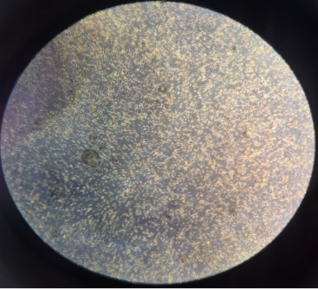  D
Figure 1. Brightfield images at Day 0=A, Day 3=B, Day 7=C, and Day 10=D. Leica DMi1, 10×. 10 µm scale bar. Panels labeled A–D.
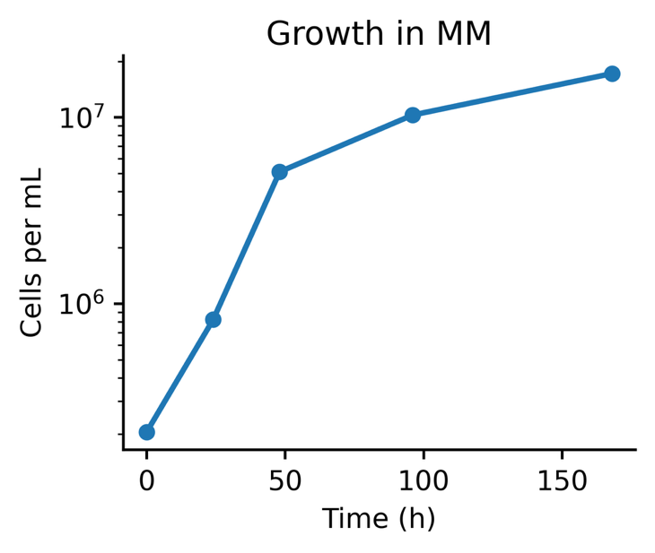
Figure 2. Growth curve in MM at 0, 24, 48, 96, 168 h with mean ± SD. Fit a single exponential across 0–168 h and report the doubling time.
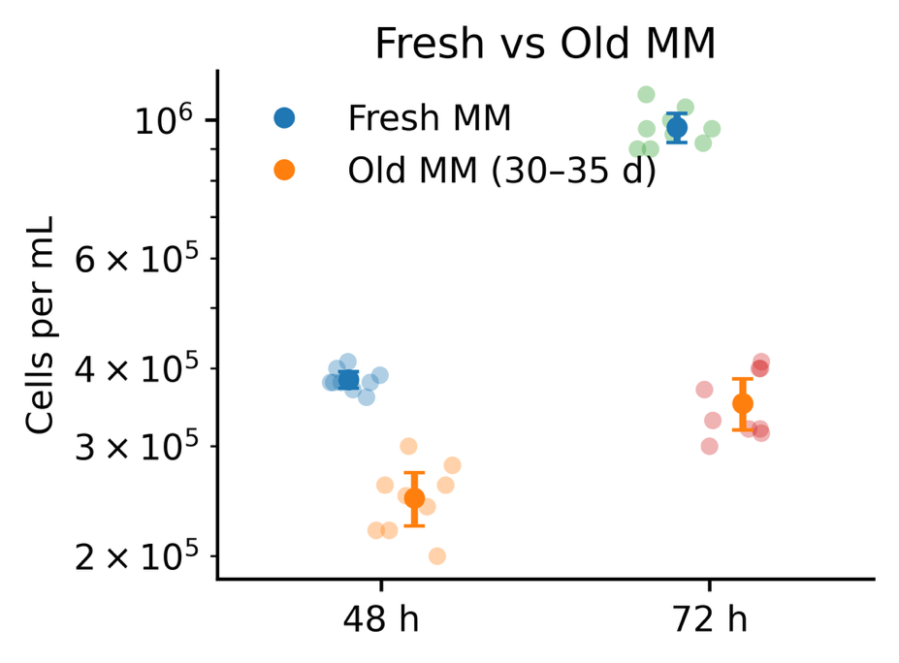
Figure 3. Fresh versus old MM at 48 h and 72 h. Show point estimates with 95% confidence intervals and annotate Fresh:Old ratios. (≈1.55 at 48 h; ≈2.77 at 72 h).

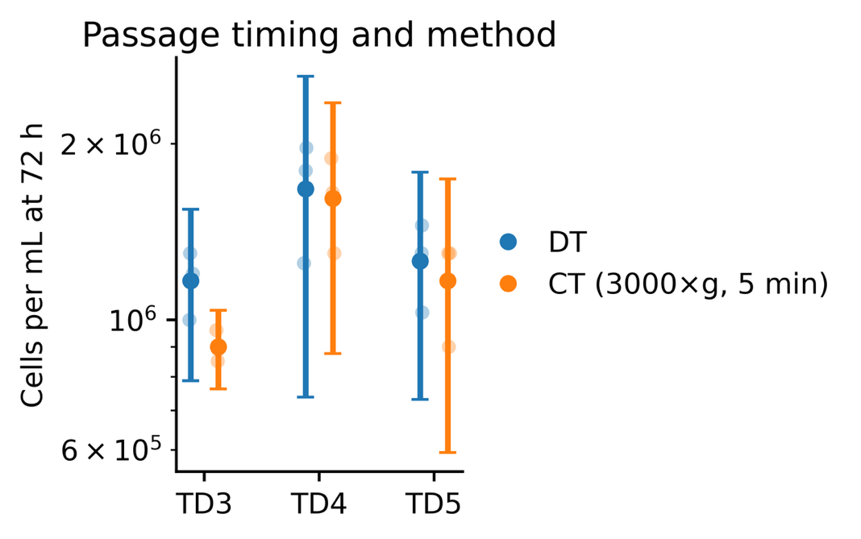
Figure 4. Passage timing and transfer method. TD3, TD4, TD5; DT shows the largest margin at TD3; TD4 is close; TD5 is similar. Points are means; vertical lines show variation across replicates.
Figure 5. Cost, serum status, and doubling time. Bars show cost ranges per 100 mL. Hatching marks media made with 10% FBS; MM has no serum. Points on the right axis mark doubling time: MM shows the overall value (~28 h). Nelson-type shows the mean with an error bar spanning 18.5–29.6 h. PYNFH-type and DMEM+10% FBS are not plotted for doubling time because standard values for N. fowleri are not established.
Supplementary Information for “Montenegro’s Medium (MM)”

S1. Materials and equipment
Reagents
- Trypan blue solution for viability checks.
- Dish microscopy for weekly contamination check.
- DMEM and fetal bovine serum for comparator runs.
Consumables
- Sterile syringe filters, nominal pore size 0.22 µm.
- Culture flasks: T-25 and T-75.
- Glass hemocytometer with coverslips.
- Pipettes and sterile tips, serological pipettes, sterile tubes.
Instruments
- Class II biosafety cabinet.
- CO₂ incubator at 37 °C, 5 percent CO₂.
- Inverted microscope Leica DMi1, brightfield, 10× objective.
- Bench centrifuge capable of 3000×g.

S2. Prepare MM (1×, 1 L)
Component | Identity / hydration | Amount per 1 L
Sodium chloride | NaCl (anhydrous) | 12.0 mg
Sodium phosphate Dibasic Heptahydrate | Na₂HPO₄·7H₂O | 14.2 mg
Potassium dihydrogen phosphate | KH₂PO₄ | 13.6 mg
Magnesium sulfate heptahydrate | MgSO₄·7H₂O | 0.40 mg
Calcium chloride dihydrate | CaCl₂·2H₂O | 0.40 mg
Liver infusion powder | (liver hydrolysate) | 0.17 g
D-glucose | C₆H₁₂O₆ (anhydrous) | 0.17 g
- Add 800 mL of ddH₂O (18 MΩ·cm water) into a sterile glass bottle.
- Add salts in the following order and stir gently:
NaCl → Na₂HPO₄·7H₂O → KH₂PO₄ → MgSO₄·7H₂O → CaCl₂·2H₂O.
- Add D-glucose; mix until dissolved.
- Add liver infusion powder slowly while stirring until fully dispersed.
- Adjust volume to 1,000 mL with ddH₂O.
- Do not autoclave.
- Sterilize by filtration: PES 0.22 µm syringe filter into sterile bottles or another sterile glass bottle.
- Label with an ID plus date, then split and stored as needed.
Storage and handling
- Store at 4 °C, protected from light.
- Use within 1–2 weeks.
- Before use: warm to room temperature and mix gently.
- Serum: not used.
Quality control:
Place 3 mL of MM into a petri dish at 37 °C for 48–72 h and observe under the microscope for contamination; discard the tube if any contamination, turbidity or growth appears.

S3. Routine subculture
- Direct transfer: resuspend gently and transfer to fresh MM to reach the target inoculum
- Centrifuge transfer: pellet at 3,000×g for 5 min, discard supernatant, and resuspend in MM to the target inoculum.
- Timing: Day 3 to Day 4 is efficient for steady expansion.
- Incubation: 37 °C, 5% CO₂, static.

